The Ussher Society
Geoscience in South-West England
61st Annual Conference
Barnstaple, Devon
Thursday 11th - Saturday 13th January 2024

Conference Circular - Call for Papers & Conference Attendance

The Ussher Society is pleased to announce its 61st Annual Conference will be held at the Park Hotel, Barnstaple, Devon, from the afternoon of Thursday, 11th, to Saturday, 13th of January 2024. This 2.5-day conference for earth and environmental scientists working in South-west England and related areas includes 1 ½ days of presentations and a field excursion day. The presentation days will be Thursday afternoon on the 11th, and the whole of Friday, the 12th of January – oral and/or poster presentations will be welcomed in all areas of the geosciences relating to South-west England.

CONFERENCE PROGRAMME
South-west geology, geomorphology and palaeontology are alive and well!

The South-west of England in 2023 was identified as one of eight areas across the UK considered potentially prospective for critical raw materials by the Critical Minerals Intelligence Centre (CMIC). Long known for its mineral riches, the South-west continues to be a hub of academic and business-led science and research.

Alongside economic geology, there are exciting community science initiatives to help the South-west regional coastal monitoring programme gather data through their CoastSnap beach monitoring scheme to link beach erosion/accretion events to weather conditions, seasonal fluctuations, and extreme storm events.

Also, the UK's continuing commitment to renewable energy and, in particular, offshore wind (e.g. Celtic Sea Power) provides new opportunities to look at regional geology in a new light.

As always, our conference programme will be wide-ranging and varied, so we look forward to seeing you in Barnstaple.

Scott Simpson Lecturer: Tracy Aze (University of Leeds)
Areas of expertise: climate change; biodiversity; oceanography; micropalaeontology

Thursday 11th January
Conference Registration 13:00-13:50 (Conference start 14:00)
- Presentations: oral and poster presentations.
- Conference Icebreaker drinks 17:30 (drinks tokens included in the conference fee)
- The Conference Dinner will be in the Park Hotel at 19:00

Friday 12th January
Conference Registration 08:00-08:50 (Conference start 09:00)
- Presentations: oral and poster presentations.
- Scott Simpson Lecture/AGM
- Conference closes at the end of the afternoon session 16:45

Saturday 13th January
Conference field excursion. Please indicate if you are interested in participating in the field excursion on the Conference Booking Form: full details to follow, (lots of opportunity).

Part 1: Conference Venue / Accommodation Details
Part 2: Conference / Booking Form and Payment Details / Membership form
Part 3: Pre-order Conference Dinner Menu Form
Part 4: Contribution to the Annual Conference Programme (Talks / Posters)

Part 1

ACCOMMODATION INFORMATION
Note that it is your responsibility to make arrangements/payment for the accommodation you require before, during and after the conference. Please quote USSHER SOCIETY in any accommodation communications with the hotel.

The conference venue is the 4 star Park Hotel, 1 Taw Vale, Barnstaple EX32 9AE. Perfectly positioned at the centre of Barnstaple, The Park has a great location - close to nature and close to town. With its leafy park side setting, this stylish hotel is well away from the hustle and bustle, yet wonderfully convenient for exploring Barnstaple and the surrounding North Devon area. This Brend group hotel is a great venue to meet.

Free car parking is available at the hotel. The nearest mainline train station is Barnstaple operated by Great Western Rail. Taxis should be available at the station (about 5-minute taxi drive) or it is a 15-minute walk from the station to the Hotel.

Full details of the accommodation are available at: www.parkhotel.co.uk

Ussher Society Conference 2024 Room Rates

We have discussed with the hotel to secure discounted rates, so please mention the Ussher Society when booking. The prices quoted are maximum values, but other savings might be available on request.

Demand for rooms is likely to be high, so early booking is strongly recommended. The hotel can be contacted on 01271 372166 and has indicated they would prefer to be contacted by phone to clarify individual requirements.

Garden Court Twin/Double / Standards (in the main hotel)
- Twin / Double rooms, (single occupancy) Bed and Breakfast - £82 pppn*
- Twin / Double rooms, (two people) Bed and Breakfast - £52.00 pppn*
Park View / Superiors
- Twin / Double rooms, (single occupancy) Bed and Breakfast - £94 pppn*
- Twin / Double rooms, (two people) Bed and Breakfast - £64.00 pppn*
Deluxe (Garden Court / Park View Balcony / Deluxe Park View Balcony)
- Twin / Double rooms, (single occupancy) Bed and Breakfast - £110 pppn*
- Twin / Double rooms, (two people) Bed and Breakfast - £80.00 pppn*

*pppn(per person per night)

Note: Other room styles e.g. Single rooms etc. are available on enquiry.

Terms and Conditions:
1. Deposits will be equivalent to the 1st night stay and are non-refundable
2. Cancellations will be determined by the hotel and information provided on booking
3. On check-in remaining payment will be taken
4. All room types are subject to availability and are on a first-come, first served basis.

Alternative accommodation can be found in Barnstaple e.g. The Barnstaple Hotel or the Royal and Fortescue Hotel.

Part 2

Please ensure the return of the conference booking form and payment by Sunday 7th January 2024.

Note: A number of bursary funds are available to contribute towards the cost of full-time students wishing to attend the meeting to present a paper or poster (contact Andrew Green using Conference@ussher.org.uk for details).

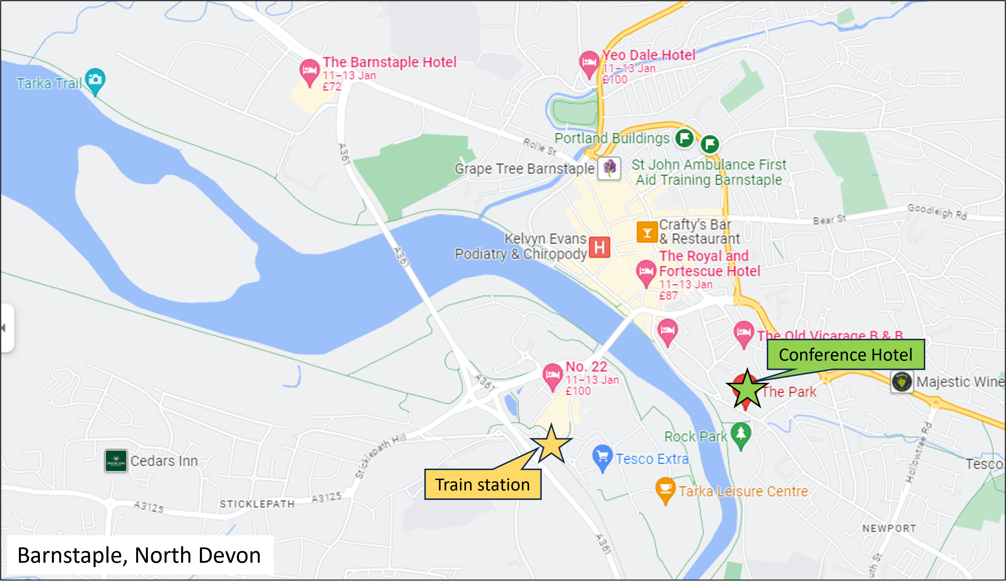

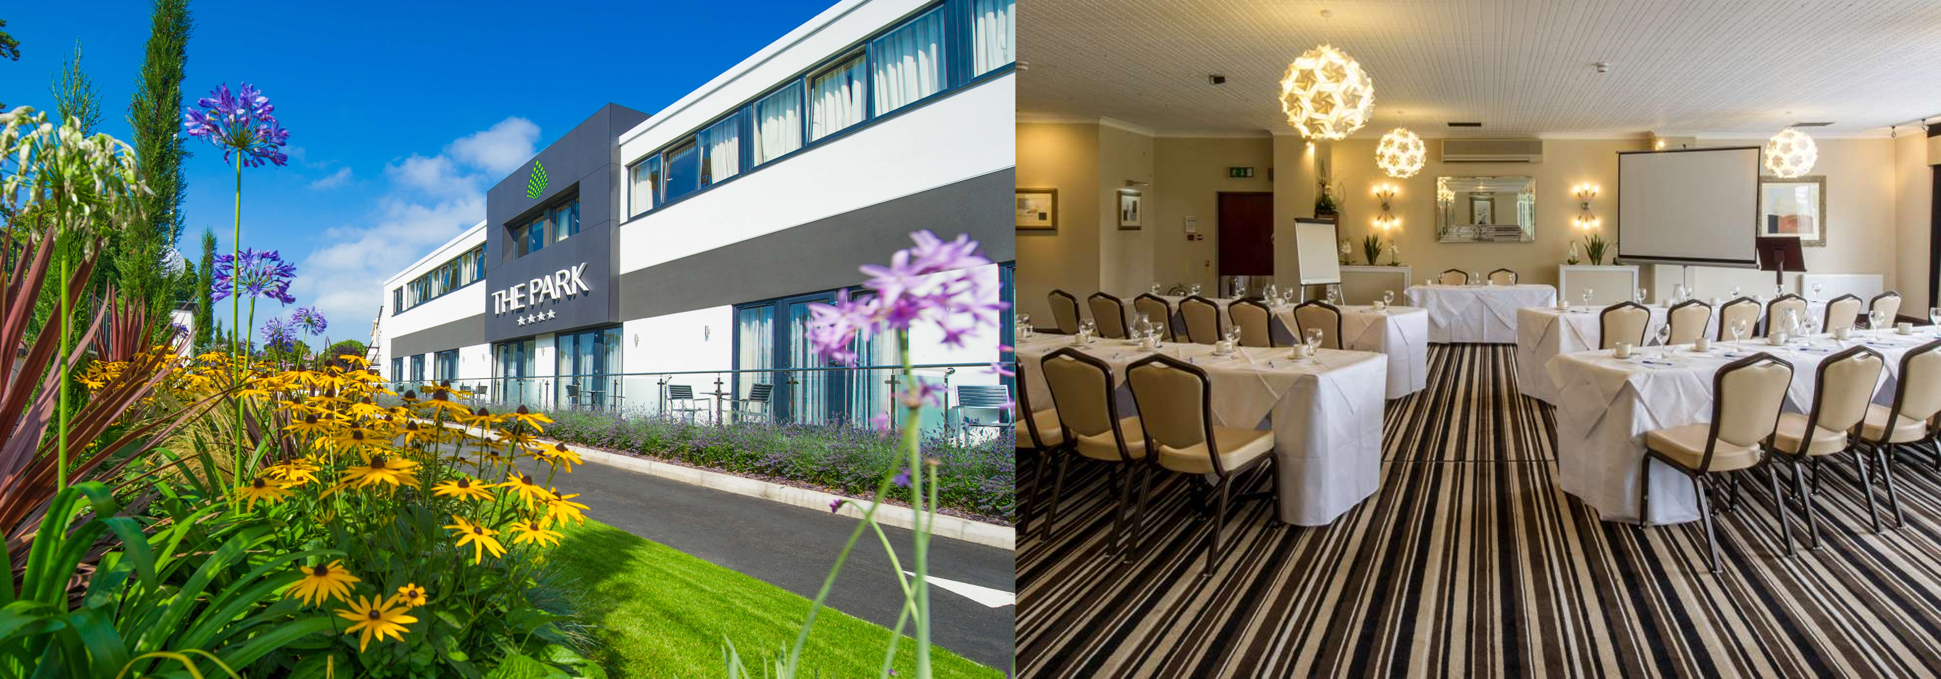

Conference Coordinators 2024: Andrew Green / Andy Fleet / Kevin Page
Please return conference forms and payment to:

Ussher Conference, Andy Fleet, Stour Brook House, Cookswell, Shillingstone, Blandford, Dorset, DT11 0QZ.
Email: Conference@ussher.org.uk

Please address payment to "Ussher Society Conference"
BACS payment to: Sort Code 40-20-30 Account No 91039059 Ref: YourNameB24
Cheque payment to: Ussher Society Conference Ref on cheque back YourNameB24

Your name (1st initial+Surname+B24) e.g. AGreenB24 as BACS Ref is important for us to monitor payments.

CONFERENCE BOOKING FORM
The Ussher Society 61st Annual Conference – The Park Hotel, Barnstaple
Thursday 11th – Saturday 13th January 2024

NAME:

Member of Ussher Society: YES / NO

Name (& Affiliation) for Conference Badge:

ADDRESS:

Telephone: Mobile:

Email:

To reduce costs, we shall use email for contact where possible.

I wish to register for the conference as follows (please tick where appropriate):
**Subsidised Conference Rates apply for current fully paid members only
Complete the membership form on the next page to become a member.
If you have questions regarding your membership status please email: secretary@ussher.org.uk
Member Rate**

@ £15.00

Non-Member Rate

@ £47.50

Full-time Student Rate

@ £15.00

N.B. Registration includes morning/afternoon tea/coffee and lunch on Friday at the conference venue. Vegetarian and gluten free options will be provided for.

Conference Dinner on Thursday 11th January @ £30.00 for 3 courses and coffee

I wish to book the Conference Dinner for …..… person(s) @ £30.00 pp = £

Vegetarian, vegan and gluten-free options will be provided.

Please see below for the menu options and pre-order forms for attendees and plus 1’s

I make payment for £ …………… to “Ussher Society Conference” - by BACS / Cheque (attached) Please mark to indicate

Signature: …………………………. Date: ……………….

Please tick if you require a receipt: ……….. (provided at conference registration)

Field Excursion
I am interested in participating on Saturday 13th January 2023: YES /NO for …..… person(s)
(Please circle to indicate your initial intentions; details will follow).
(Note that at this stage, we are only interested in the likely number of participants.)
THE USSHER SOCIETY
Application for Membership
Title ...........................
Surname .................................................Forenames...............................................................
Address for correspondence
......................................................................................................................................................
......................................................................................................................................................
..............................................................................................................................................
Post Code.................................................................................
Phone/Mobile (incl area code).................................................................................
Email (preferably personal).................................................................................
Category of membership (and annual subscription) - please tick:
Ordinary (£30)
Student (£12)
University:
Name of Supervisor: Date
Signature of Supervisor:
--------------------------------------------------------------------------------------------------------
Either: 1) Set up a standing order with your bank to come out on the 1st of January each year.
The Ussher Society: Account – 91039059, Sort code - 40-20-30 (HSBC Bank) and email the completed application to Secretary@ussher.org.uk & Treasurer@ussher.org.uk

or
2) Send the completed application with cheque payment to the Treasurer:

Mr D. Roche,
Cheques for the annual subscription should be made payable to The Ussher Society.
Ussher Society (Hon Treasurer),
47, Rivermead Road
Exeter, Devon
EX2 4RH

I give the Ussher Society permission to use my contact details, for Ussher Society use only, as detailed in the Ussher Society Privacy Policy.

Please see Ussher Society Privacy Policy on our website: http://ussher.org.uk/membership
Part 3 – Conference Dinner Menu Pre-Order #1
STARTERS

- CREAM OF VEGETABLE SOUP with Herb Croutons V GF? VE?

- CLASSIC PRAWN COCKTAIL GF?
Iceberg lettuce, Marie rose sauce, brown bread & butter

- HOMEMADE CHICKEN LIVER PATE GF?
Toasted brioche, apple chutney, quince jelly

- WILD MUSHROOM ARANCINI BALLS VE
Spiced mayonnaise, tomato vinaigrette

MAINS

- ROAST LOIN OF PORK GF?
Apple sauce and stuffing

- GRILLED FILLET OF SALMON GF
Red pepper gremolata, herb oil

- BREADED BUTTERNUT SQUASH GF VE
Blue Katsu curry sauce, braised rice

- PAN FRIED CHICKEN SUPREME GF
Mixed White bean & wild mushroom ragu, truffle oil

DESSERTS

- RASPBERRY PANNA COTTA V GF
Raspberry coulis, mini meringue

- WHITE CHOCOALTE & PASSION FRUIT CHEESECAKE V
Vanilla ice-cream, raspberry coulis

- FRESH FRUIT PLATE V GF? VE?
A selection of mixed fruit, fresh sorbet

- WESTCOUNTRY CHEESE AND BISCUITS V GF?
Hawkridge mature cheddar cheese, brie, blue, red onion chutney, celery, grapes
Tea, Coffee and Chocolate Mints

VE Vegan VE? Can be Vegan indicate when ordering V Vegitarian GF Gluten Free GF? Can be Gluten Free indicate when ordering

Name: __________________________________________

Dinner Course | Select option number from menu  and VE, V or GF if required (please circle)
Starter: 1, 2, 3 or 4 |  | Require alternative: VE V GF
Main: 5, 6, 7 or 8 |  | Require alternative: VE V GF
Dessert: 9, 10, 11 or 12 |  | Require alternative: VE V GF
Part 3 – Conference Dinner Menu Pre-Order #2
STARTERS

- CREAM OF VEGETABLE SOUP with Herb Croutons V GF? VE?

- CLASSIC PRAWN COCKTAIL GF?
Iceberg lettuce, Marie rose sauce, brown bread & butter

- HOMEMADE CHICKEN LIVER PATE GF?
Toasted brioche, apple chutney, quince jelly

- WILD MUSHROOM ARANCINI BALLS VE
Spiced mayonnaise, tomato vinaigrette

MAINS

- ROAST LOIN OF PORK GF?
Apple sauce and stuffing

- GRILLED FILLET OF SALMON GF
Red pepper gremolata, herb oil

- BREADED BUTTERNUT SQUASH GF VE
Blue Katsu curry sauce, braised rice

- PAN FRIED CHICKEN SUPREME GF
Mixed White bean & wild mushroom ragu, truffle oil

DESSERTS

- RASPBERRY PANNA COTTA V GF
Raspberry coulis, mini meringue

- WHITE CHOCOALTE & PASSION FRUIT CHEESECAKE V
Vanilla ice-cream, raspberry coulis

- FRESH FRUIT PLATE V GF? VE?
A selection of mixed fruit, fresh sorbet

- WESTCOUNTRY CHEESE AND BISCUITS V GF?
Hawkridge mature cheddar cheese, brie, blue, red onion chutney, celery, grapes
Tea, Coffee and Chocolate Mints

VE Vegan VE? Can be Vegan indicate when ordering V Vegitarian GF Gluten Free GF? Can be Gluten Free indicate when ordering

Name: __________________________________________

Dinner Course | Select option number from menu  and VE, V or GF if required (please circle)
Starter: 1, 2, 3 or 4 |  | Require alternative: VE V GF
Main: 5, 6, 7 or 8 |  | Require alternative: VE V GF
Dessert: 9, 10, 11 or 12 |  | Require alternative: VE V GF
Part 4
CONTRIBUTION TO THE SCIENTIFIC PROGRAMME
The Ussher Society 61st Annual Conference – The Park Hotel, Barnstaple
Presentation days: Thursday 11th – Friday 12th January 2024

If you wish to make a contribution to the conference programme, please either complete and post this form or e-mail the same information to Kevin Page (Conference@ussher.org.uk) as an attached MS Word compatible document by Friday 22th December. Confirmation of acceptance will be sent to the author(s) once It has been reviewed by the committee and again when the programme is finalised. Abstracts for both oral presentations and posters will be published in the printed conference programme and if you give acceptance (see below) will be published on the Ussher Society website as a record of the meeting in our annual conference abstract volume.

Facilities are now in place for those authors wishing to convert their abstracts into full Journal articles to have them professionally published through our society website free of charge with a quick turnaround time and high print quality. More information will be provided during the AGM.

Postal Address:
Ussher Conference, Andy Fleet, Stour Brook House, Cookswell, Shillingstone, Blandford, Dorset, DT11 0QZ.
Email: Conference@ussher.org.uk

LEAD AUTHOR NAME:

TELEPHONE/Mobile:

EMAIL (Students please provide a personal non-university email):

I / WE INTEND TO OFFER:

ORAL PRESENTATION POSTER (please tick which or both)

I / WE PERMIT OUR ABSTRACT TO BE PUBLISHED ON THE USSHER SOCIETY WEBSITE as part of the conference abstract volume (including affiliation / email)
(please tick if you consent)

TITLE:

AUTHOR(S):

Affiliation / ADDRESS (important for abstract volume):

ABSTRACT (MAX 300 WORDS and 1 Figure (can be a collage of several images as you would see in publication)

