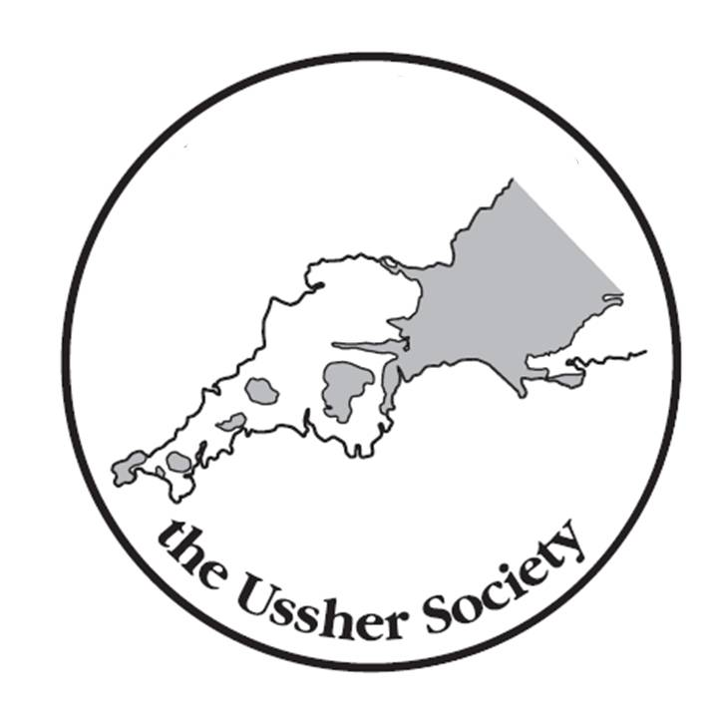

The Ussher Society
Geoscience in South-West England

61st Annual Conference
11th to 13+^{th} January 2024
Park Hotel, Barnstable, Devon

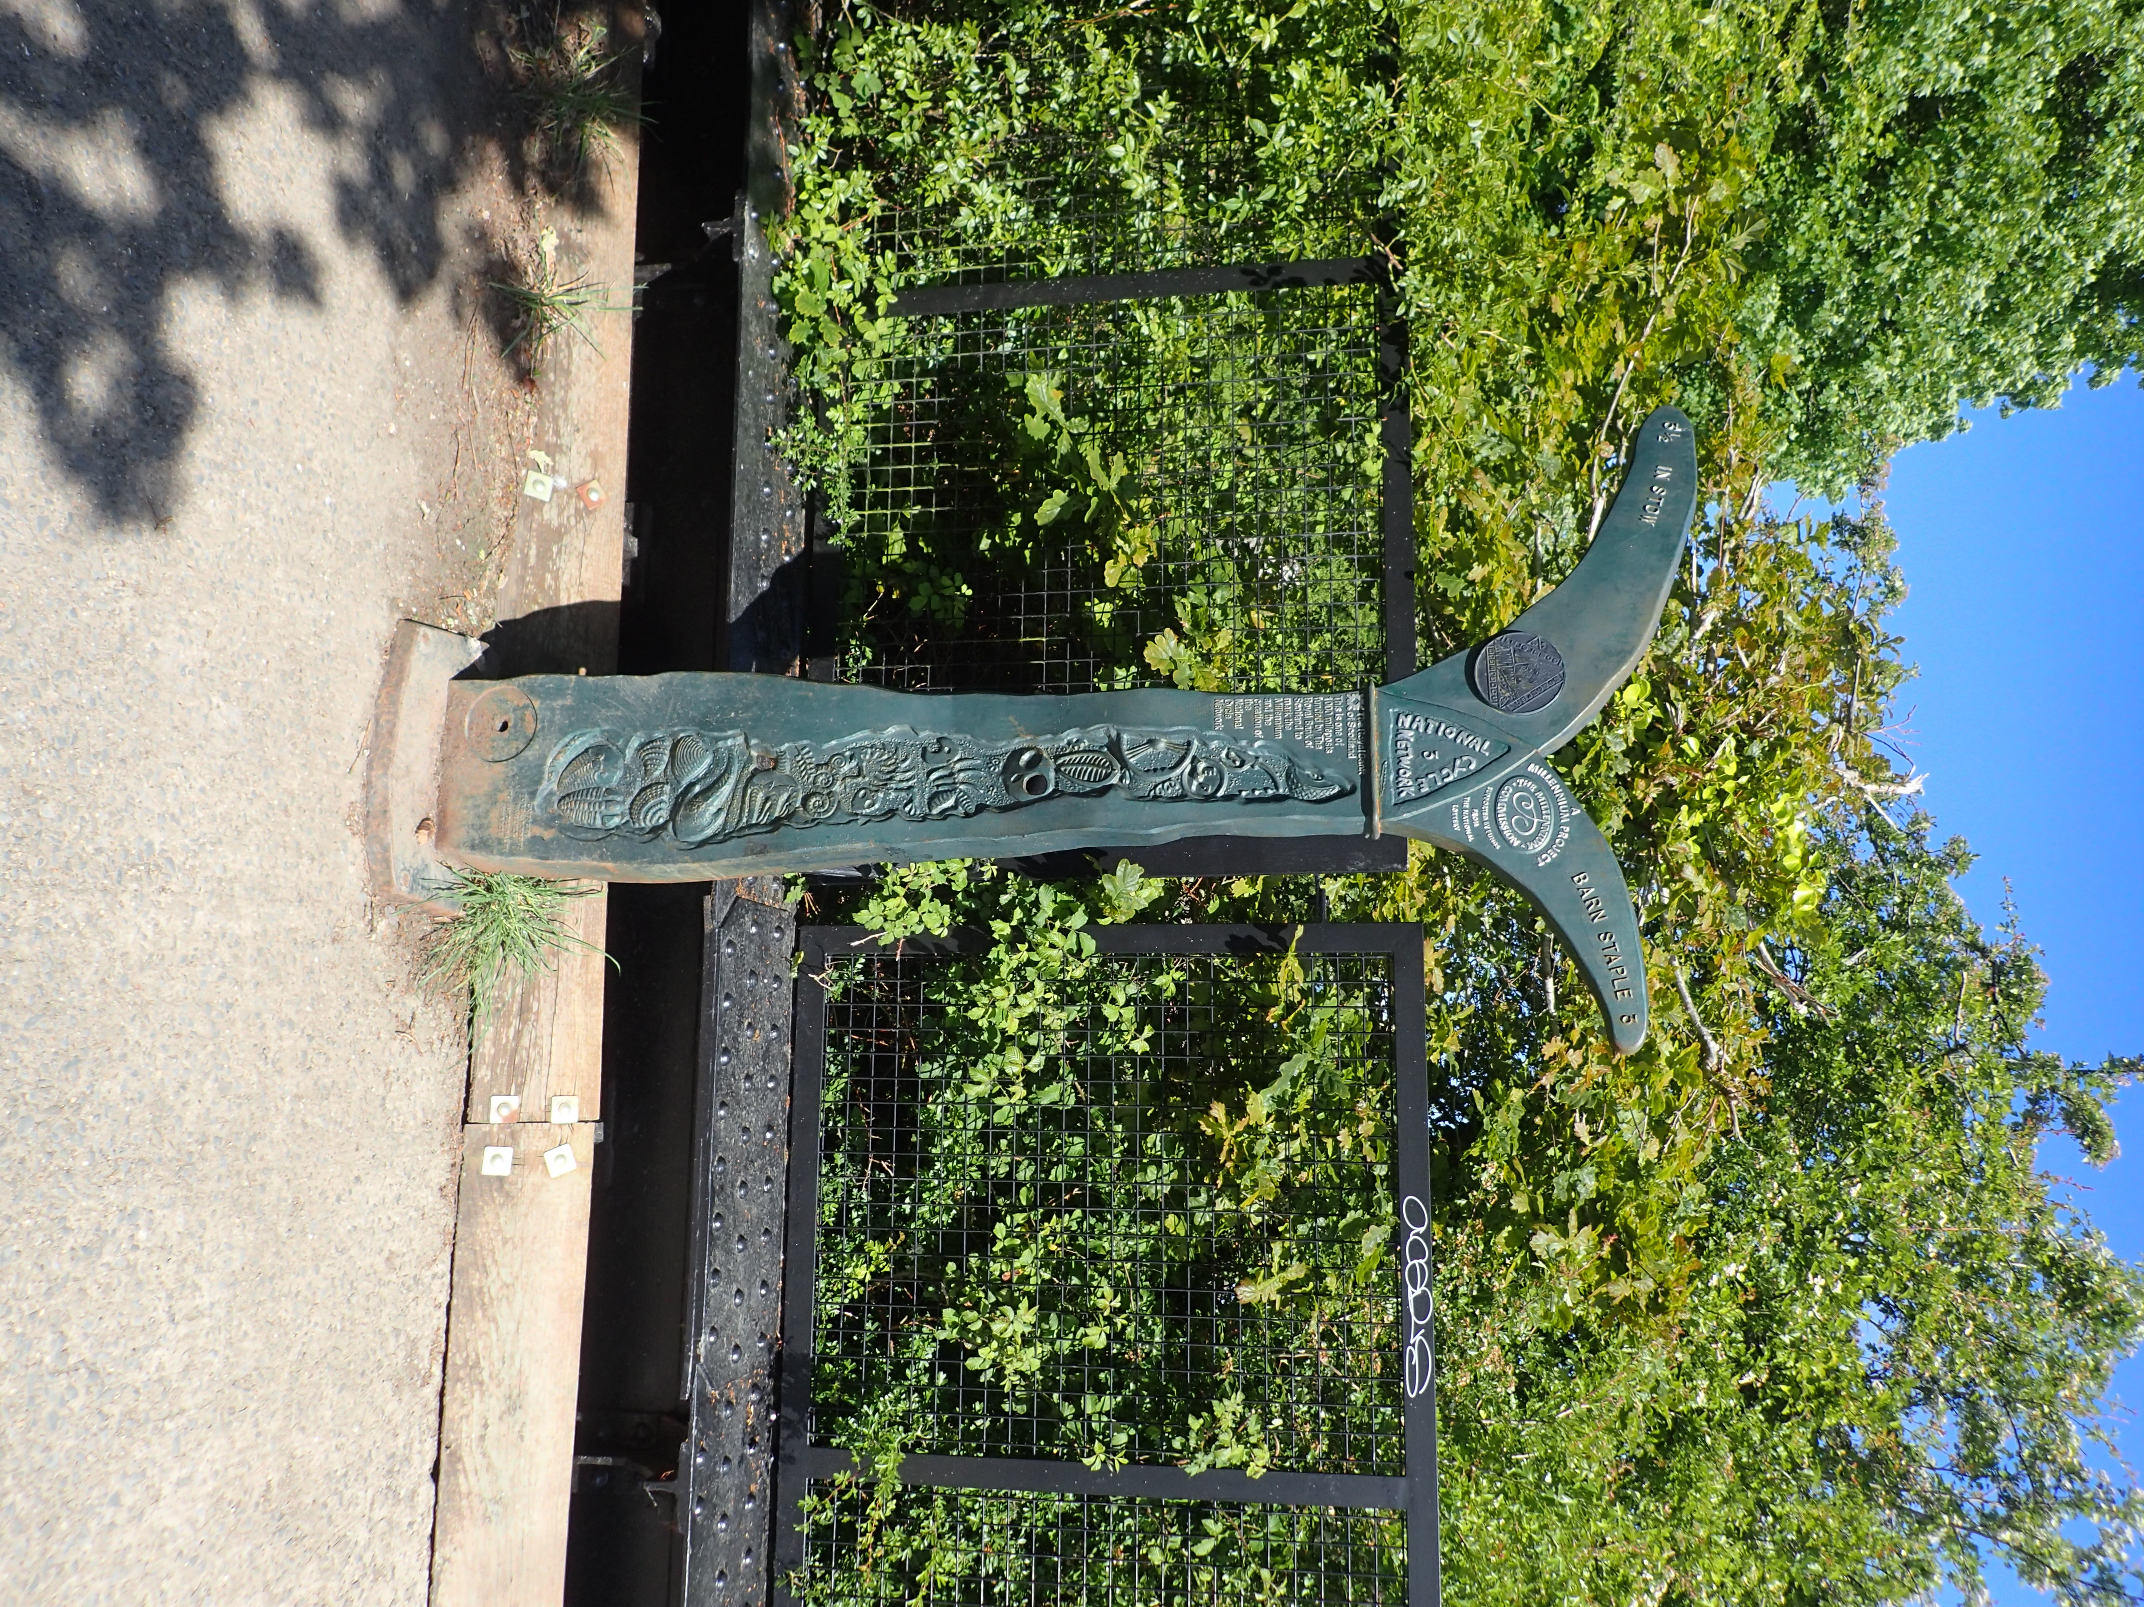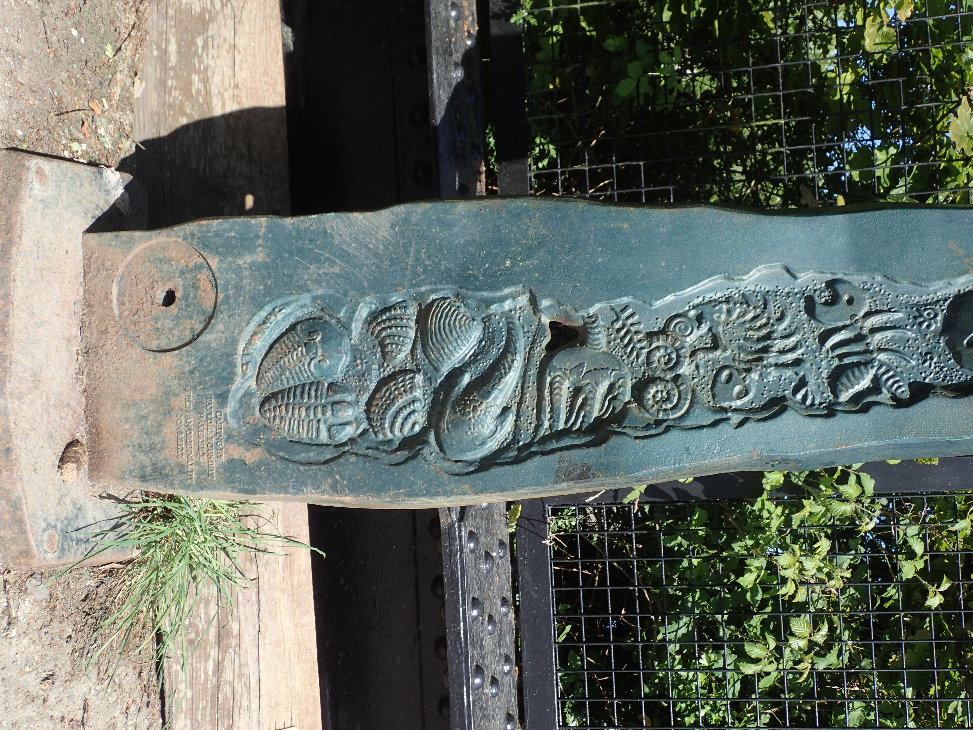

A celebration of local Devonian and Carboniferous geology on an installation beside the Tarka Trail at Fremington Quay

Conference Programme

THURSDAY 11TH JANUARY
13.00 - 14:15 | Registration
14.00 - 14:15 | Chairman’s welcome and notices
14:15 - 14:45 | Kevin Page | New observations on the sedimentary and tectonic evolution of the Devonian successions of eastern South Devon
14:45 - 15:15 | Cian McAuley, Alex Brasier, Kevin Page, Joyce Neilson | Corals, dirt and carbon: new investigations of the Devonian limestones of Eastern South Devon
15:15 - 15:45 | David Tyler | The Bude Formation as a product of tectonics
15:45 - 16:15 | Tea break
16:15 - 16:45 | Geoffrey Warrington* | Dating the Permian in Devon – A synthesis
16:45 - 17:15 | Charlie Moon | Geochemistry of the Gunnislake Granite: an example of small granite variability
17:15 - 17:45 | Philip Mark Henes, Robin K. Shail, Hylke J. Glass  Sam Broom-Fendley,  Christopher J. Dalby, Gavyn K. Rollinson | Mineralogical, geochemical and mineral chemistry results from the longest onshore well in the UK, EG-1, a 4.5 km deep geothermal well in the Cornubian Batholith
17:45 - 18:00 | Discussion / Day 1 closing remarks
18:00 - 19:15 | Conference Icebreaker reception
19.30 - Late | Conference Dinner

Please wear your badge to indicate that you have registered.
Morning & Afternoon Coffee/Tea and Lunch
These are included in your registration fee.

Conference Icebreaker Reception
Drink Tokens included in your registration fee.

FRIDAY 12TH JANUARY
08:00 – 08:50 | Registration
09:00 - 09:30 | Steve Jermy | Floating offshore wind in the Celtic Sea
09:30 - 10:00 | Chris Dalby, Robin Shail, Gavyn Rollinson, Simon Tapster, Tony Batchelor, James Hickey, Lucy Cotton, Frances Wall | Cornubian Batholith construction and the regional heat flow anomaly viewed from the United Downs Deep Geothermal Power Project UD-1 well (5054 m)
10:00 - 10:30 | Sally Worbey, Alexander J. L. Hudson, William Irani, Adam Matthews, Mike Round | Cornish Lithium: Exploration for lithium-enriched geothermal waters in Cornwall, England
10:30-11:00 | Coffee break
11:00 - 12:00 | Scott Simpson Lecture: Tracy Aze  (University of Leeds) | Using the marine microfossil record to investigate palaeoecological responses to environmental change
12:00 - 13:00 | AGM
13:00 - 14:00 | Lunch
14:00 - 14:30 | Alan Cattell | The Old School Borehole and the Bedminster Mudstone Member.
14:30 - 15:00 | Malcolm Hart, Chris Moore, Simon Penn and Gregory Price | New records of coleoid fossils from the Lower Jurassic of South-West England
15:00 - 15:30 | Malcolm Hart | Founding of the Cretaceous System in 1822
15:30 - 16:00 | Tea break
16:00 - 16:30 | EV Stockley, LS Basell, LS Bray and H Chapman | Predicting and protecting lithic landscapes – understanding the distribution of lithics across Dartmoor, UK
16:30 - 17:00 | Kevin Page | Global Geosites and Key Geodiversity Areas – and their relevance to South West Britain
17:00 - 17:15 | Conference closing remarks
Saturday 13th January
10:00 – c.15.00 | Geological Field Trip: Fremington Quay (Devonian-Carboniferous boundary and the earliest Carboniferous facies of the Culm Basin - plus Quaternary…)

Please wear your badge to indicate that you have registered.
Morning & Afternoon Coffee/Tea and Lunch
These are included in your registration fee.

